Delivery 2
Task 1:
In the diagram we can see two entities YMLE and BAMLE. YMLE has two attributes Gru and Blipp where Blipp is a unique attribute, meaning that no YMLEs can share the same Blipp value. BAMLE has just one attribute which is also unique named Blunk. We also see that YMLE relates to BAMLE through a relation named ZLUFF where YMLE doesn’t need to ZLUFF BAMLE (at least zero) but can ZLUFF at most one BAMLE. On the other hand, BAMLE must ZLUFF at least one YMLE and BAMLE can ZLUFF as many YMLEs as it needs.
Task 2:
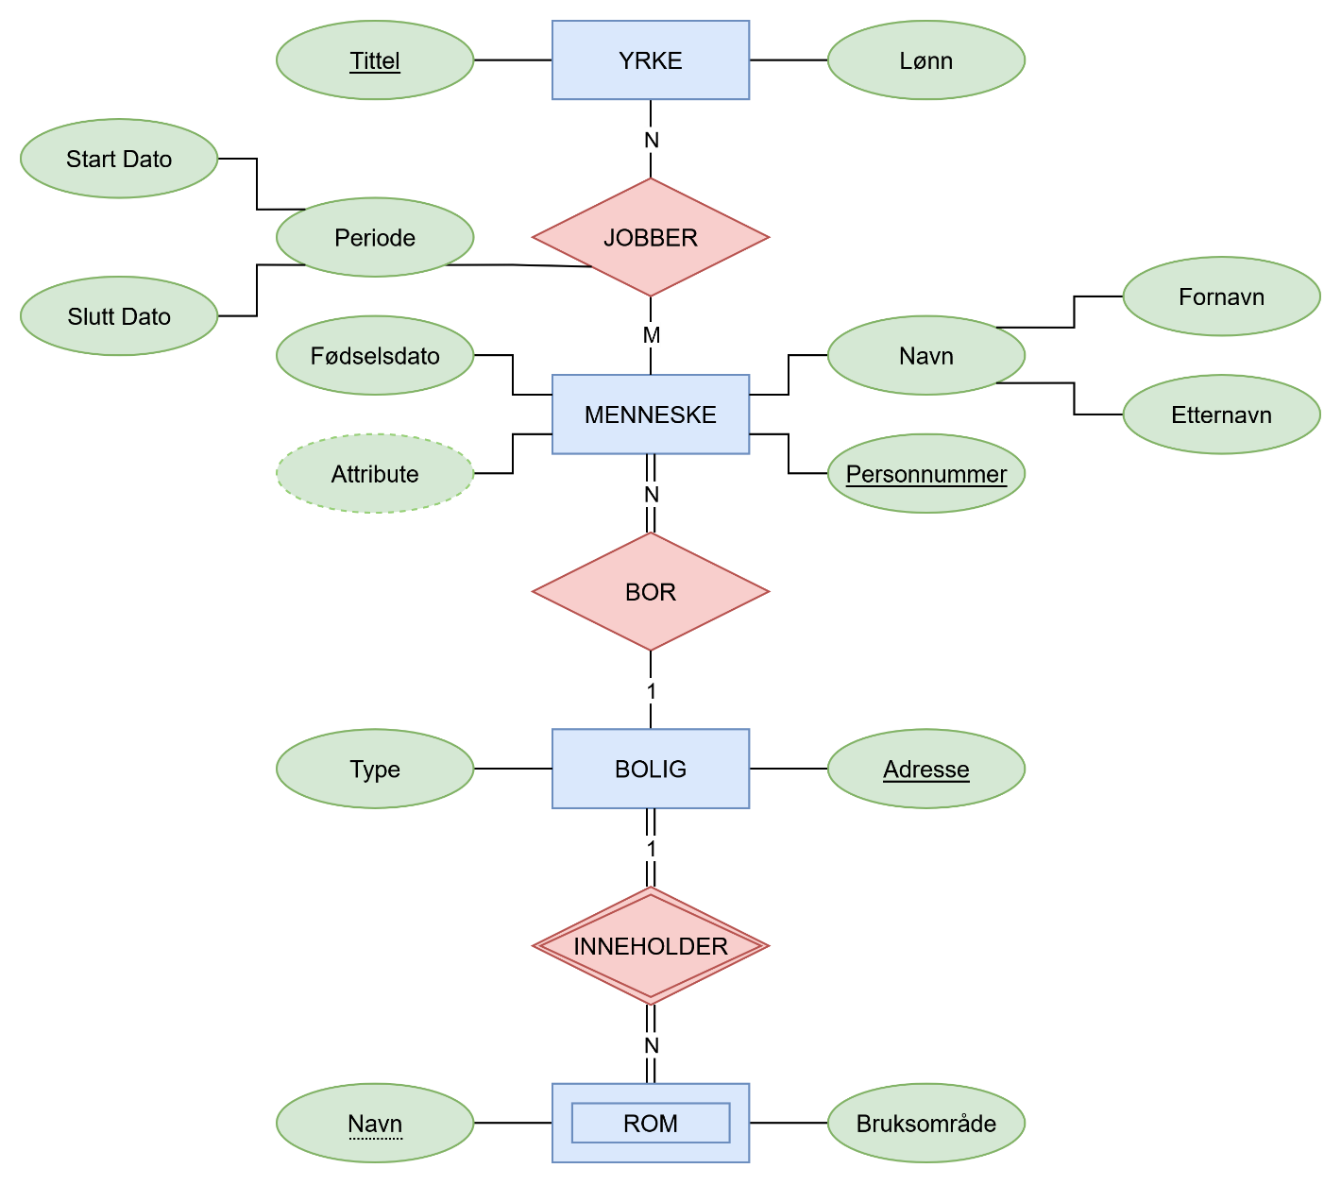

Task 3:
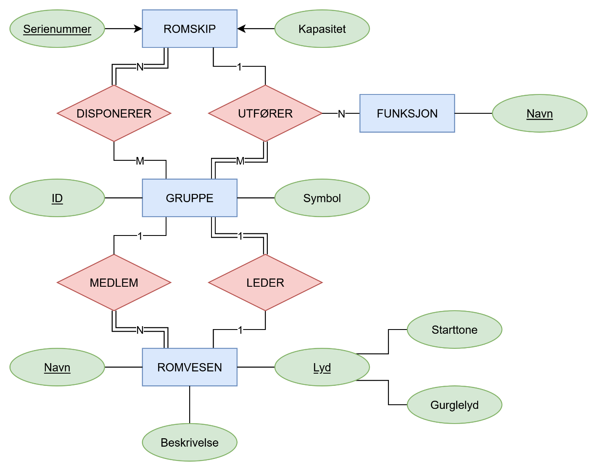
Also, I am not sure that this is how triple relation works (UTFØRER), but I do know how to make it actually work. I was just too lazy for that.
Task 4:
I was not sure if I actually had to code that in or make like in video 06-02, so I coded it in. Check out the file that came with the .zip file that has the code. The comments explain what I’ve done. As for decision, I decided to make whatever looked the best such as references in melding and vedlegg, and a table for both melding and romvesen as well as menneske and ansvarsområde. I am not sure if I can use Norwegian letters in .sql, so I replaced them with English counterparts. As for datatypes, it became whatever I felt like worked fine, not necessarily the best course of action though in real scenarios such as bytea with diagrams instead of a text of a file path for a .png or similar.

